

W IN DOW AC GAS CH ARGIN G: KEEP YOUR COOL!

A FUN GUIDE TO STAYING CHILL AT HOME

WHAT IS GAS CHARGING?

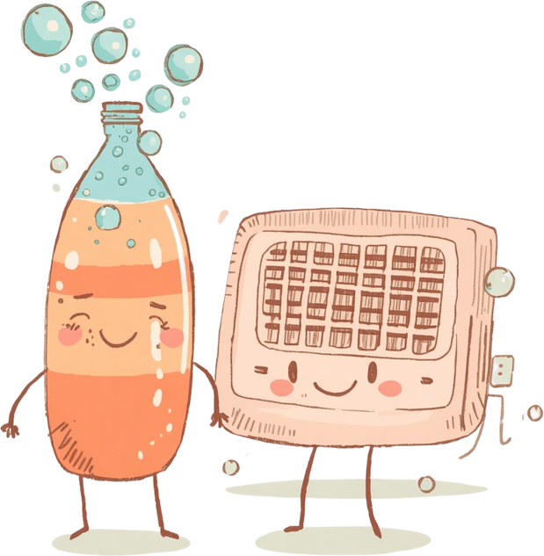
Think of your AC like a soda bottle — it
needs just the right fizz (gas) to cool your room! Gas charging is simply adding refrigerant to your AC to keep it working well and blowing cool air.
Without enough gas, your AC can't do
its fizzy magic!

WHY IS GAS CHARGING IMPORTANT?


Keep your AC happy and healthy:
Keeps your AC cooling efficiently — no more sweaty afternoons!
Saves energy and lowers bills — more money for ice cream!
Prevents damage to your unit — your AC will thank you.
Maintains optimal performance — stay cool all
summer long!

SIGNS YOUR AC NEEDS GAS

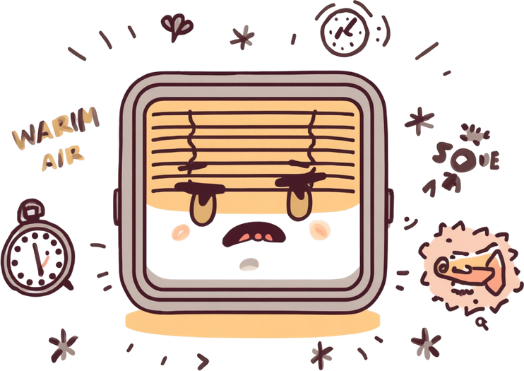
Watch out for these clues:
Warm air blowing from the AC — brrr, where's the cool?
Longer cooling times — patience is NOT a virtue here!
Frost buildup on AC coils — ice where it shouldn't be!
Hissing sounds — your AC is trying to tell you
something!

WHAT HAPPENS IF GAS IS LOW?

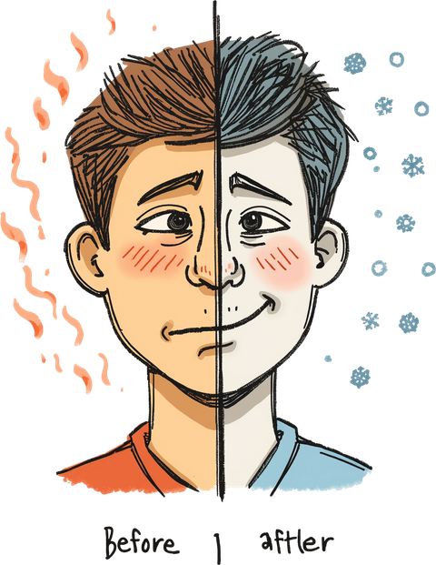

Before: Your AC struggles, the room stays warm, and you're sweating! After: Cool breeze flows, everyone's happy! Low gas = less cooling power!

Check pressure with gauges
H OW
GAS
CH ARGIN G
W ORKS

Connect refrigerant tank

Add gas until correct level
Test cooling performance

Listen for proper operation

Enjoy the cool breeze!

Wear protective gloves
SAFETY
TIPS
FOR
GAS
CH ARGIN G

Always wear safety goggles

Call a pro if unsure
Don't charge if you smell leaks

Don't overfill — less is more!

Use proper tools only

COMMON MISTAKES TO AVOID

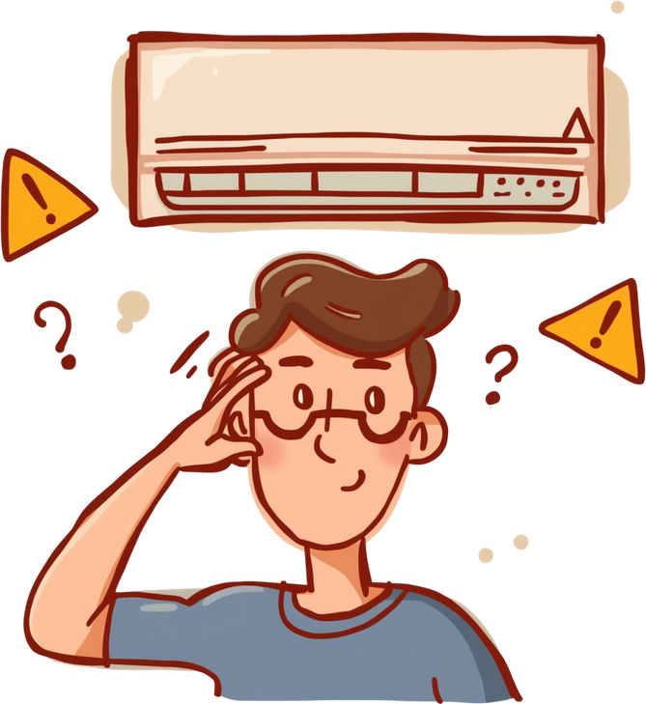
Watch out for these pitfalls:
Using the wrong type of refrigerant — not all gases are the same!
Charging without proper tools — guessing pressure levels is risky.
Ignoring leaks — adding gas to a leaky system is like filling a bucket with holes.
DIY without knowledge — a little learning goes a
long way before you try!

WHEN TO CALL A PRO


Sometimes it's best to leave it to the experts
— they have the right tools and know-how to get your AC running perfectly!
If you're unsure about gas levels, smell leaks, or don't have proper equipment, a professional
technician can help safely and quickly.

COOL RECAP!

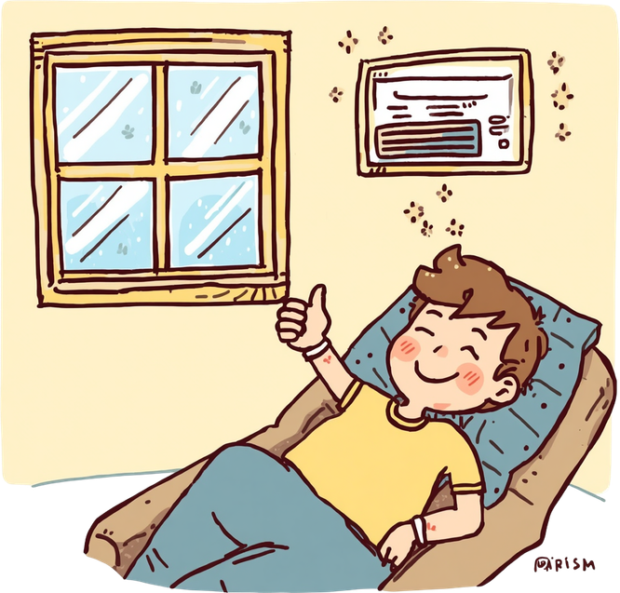
Let's wrap up what we learned:
Gas charging keeps your AC fizzing strong. Watch for signs like warm air or frost.
Safety first — use the right gear or get a pro.
Keep chill and stay cool this summer!



STAY COOL!
QUESTION S & TH AN KS!
THANKS FOR CHILLING WITH US! ANY QUESTIONS?

WWW. MYGENIE. IN

